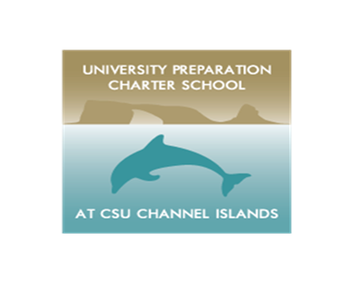

**UNIVERSITY PREPARATION CHARTER SCHOOL AT CSU CHANNEL ISLANDS**

1099 Bedford Drive

Camarillo CA, 93010

805-482-4608 – phone **** 805-512-8149 - fax

Dear Parent or Guardian:

At the end of last school year, students in grades three through eight participated in the California Assessment of Student Performance and Progress.

Last year, your child took the following test(s), depending on their grade level:

• Smarter Balanced Summative Assessments for English language arts/literacy (ELA) and mathematics in grades three through eight

• California Science Test (CAST) in grades five and eight

**Student Score Reports can now be accessed electronically through Parent Connect (Q student information system). Please click on “Tests” in the left sidebar menu. Scroll down to “California Electronic Score Reports”. Your child’s test reports will populate by year. When you click on the report button, you will generate a pdf copy of the test report.**

This report shows scores for ELA and mathematics. It includes an overall score for each subject and information about how well your child did in different areas. Students in grades four through eight who took the test in previous years will also see past scores so you can see your child’s progress over time.

To learn more about your child’s scores, go to the new parent web page called Starting Smarter, available at <https://ca.startingsmarter.org/>.

This site includes:

• resources to help understand results on the student score reports

• access to sample test questions and practice tests

• no-cost resources to support learning

• a guide for parent-teacher conferences

In our district, the test results are just one way to look at how well our students are doing.

We use the results to find areas where students are doing well and areas in which they need help. It is also important to know that the test results are not used to determine whether a student moves to the next grade.

Note: If your child took the CAST, the results will be provided in the late fall.

If you have questions or concerns, please contact your school office.

Sincerely,

Verónica M. Solórzano

Verónica M. Solórzano

Director